**Updating Account number for MIS cases**

In some cases the account number of cases are not updated.

Upon user requests, we update the Account number in DB once the needed details are provided.

For CC# 4105194, the account number was reported to be missing.

User provided the correct account number to be 8310004121552.

To first investigate the case 4105194, we execute the following query

select table_ams_account.rowid, table_ams_account .* from

table_ams_account where ams_account2billing in (select sof2billing from table_sof where objid in (select case2sof

from table_case where id_number ='4105194'))

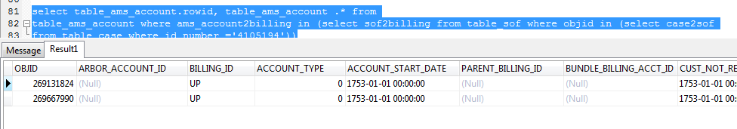

As it can be seen the arbor account id is missing.

Subsequently, the update query is executed which is as follows

update table_ams_account set arbor_account_id = '8310004121552' where ams_account2billing in (select sof2billing from table_sof where objid in (select case2sof

from table_case where id_number ='4105194'))

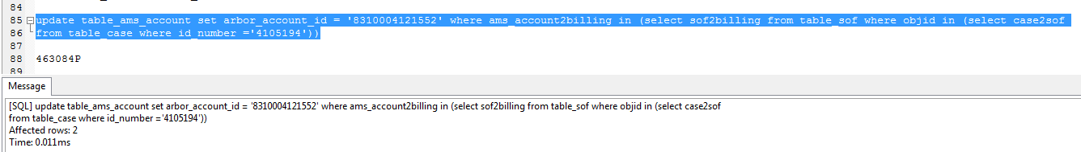

It can be now seen that the field is appropriately populated.

